INDUSTRIAL SURVEYING

3

3

3

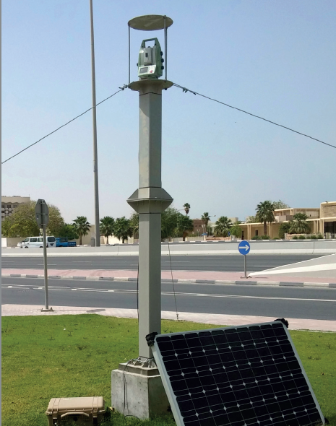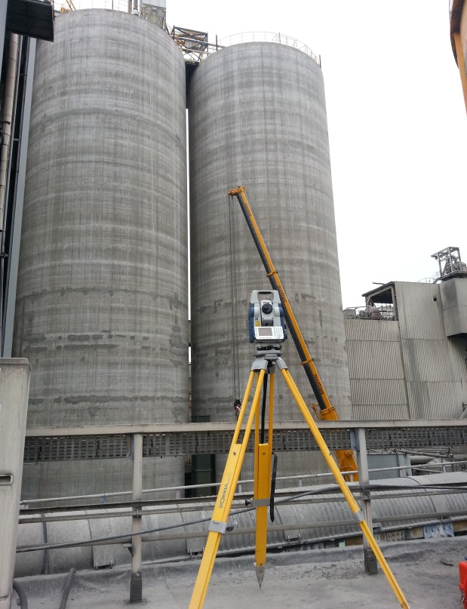

* WFGD UNIT at UNIT III of PPC S. A, Megalopolis
* Real time deformation monitoring on tanks surface during hydrotest period.
* Structural monitoring on structures and building across the projects boundaries during erection period.
* High accuracy monitoring network establishment consisting of 170 monitoring prisms on structures in the zone of influence.
* Zero measurement calculation for long term monitoring reasons.

* Stavros Niarchos Foundation Cultural

Center (SNFCC), Kalithea

* Deformation monitoring on structures and adjustments building around the site.
* Deformation monitoring and landslide examination on structures during earthworks period.
* Automated Monitoring System (AMS) installation – deformation monitoring on support frames during casting.
* AMS installation – deformation monitoring on Canopy’s period during depropping and uplift period.
* ‘’Gold Line Underground ‘’, Doha, Qatar.
* Network installation in the Zone of influence (ZOI)
* Monitoring prism and pins installation on structures and buildings in the Zone of influence.
* Deformation monitoring – Automated Monitoring System (AMS) installation
* Deformation monitoring on piles and on adjacent buildings structures during earthworks periods.

Gold Line Metro, Doha

WFGD UNIT at UNIT III of PPC S. A, Megalopolis

6

DEFORMATION MONITORING

Surveying Precision







3

High Pressure Natural Gas and Regulating Station, Tema, Ghana

3

3

INDUSTRIAL SURVEYING

INDUSTRIAL SURVEYING

3

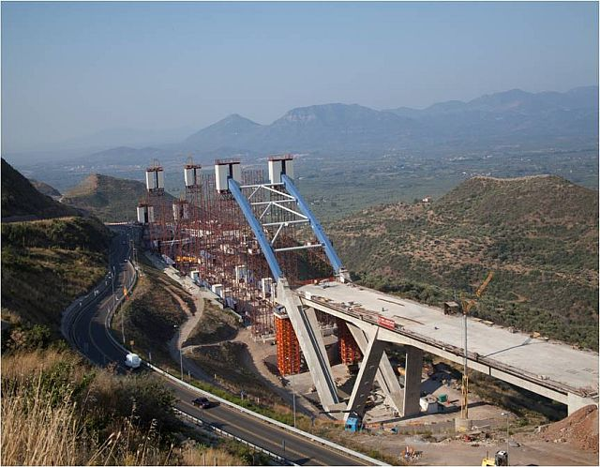

Karouzos Station Shopping Center, Attica

DEFORMATION MONITORING

* Acknowledge of the project requirements
* Planning, action, equipment, personnel and methodology.
* Placement of markers at points of interest
* Establishment of trigonometric micro- movement network outside the project zone of interest
* Network measurement and re-solution
* Taking measurements of reference regarding monitoring markers and each of the reference points
* Execution of frequent monitoring measurements regarding the markers
* Presentation of results in TIME & DISTORTION diagrams

The deformation monitoring of a land or construction represents a systematic action of observation, measurement and analysis of the way they respond to influence of surrounding agents, taking permanently in consideration the projection parameters of functionality, stability and safety.

For a proper monitoring of construction behavior in time constructions that are subjects to experimental solicitation obtaining observations in a relative short time in highly required.

APPLICATIONS

Tsakona Bridge, Kalamata

In particular, some of the application of this methodology have been used in :

* Dams
* Roads
* Tunnels
* Bridges and overpasses
* Multistory and historical buildings
* Foundations
* Mining- exploitation
* Landsides and sloping
* Earthquake- prone regions

METHODOLOGY

DEFORMATION MONITORING

www.aksm.gr